**SE401: Software Quality Assurance & Testing**

# Activity 6.2-JUnit and Coverage Testing

## Objective:

Learn how to use

* JUnit for unit level testing
* EclEmma to measure the coverage of Unit Testing.

## Setup Instructions:

* Install the latest version of [Eclipse](https://eclipse.org/downloads/).
* On opening the link, select Windows/Mac OS X from the drop-down menu. Download **Eclipse IDE for Java Developers 64 bit.**
* We need the latest version of Eclipse to use some tools throughout the course
* Eclipse requires Java to be installed on your machine. Make sure the chosen Eclipse architecture matches your chosen Java architecture!
* For IntelliJ IDEA: <https://www.jetbrains.com/help/idea/code-coverage.html>

## Assignment:

* Start Eclipse.
* We will be using the CoffeeMaker example for unit level testing and measuring the coverage.
* Extract the zip file ‘CoffeeMaker_JUnit’and import the CoffeeMaker Junit project in Eclipse.
* Unit Testing using JUnit:
  + Create unit tests and fix the 5 bugs. Use JUnit to confirm that the bugs are fixed.
* Coverage using EclEmma:
  + We will be using EclEmma to perform the coverage tests.
  + Install **EclEmma Java Code Coverage** plugin: Open Eclipse > Help > Eclipse Marketplace > search for 'EclEmma' > click Install
  + Read about EclEmma and test coverage [here](http://www.eclemma.org/)
  + Create unit tests to achieve 90% Coverage of the CoffeeMaker, Inventory, Recipe, & Recipe Book classes.

## Submission Instructions:

* You will submit Unit Tests for CoffeMaker, Inventory, Recipe and RecipeBook java classes. (4 classes in total).
* Submit screenshots of passing JUnit tests and Emma tests a very brief explanation of what you did to accomplish the activity including test cases. The java class NOT the Test class should cover 90% of the code from Emma.
* Example Screen shot of Submission. Notice we are looking at the % coverage of edu.ncsu.csc326.coffeemaker

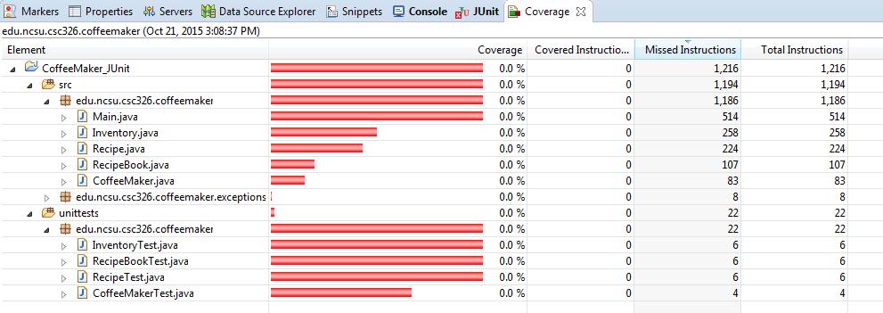

* Create a word Document and then convert it to PDF
* Write explanation and place the screenshots in the same PDF
* Submit in PDF format only.
* Submit the results of JUnit and Emma in a single PDF.

